UK & Ireland State of the Sector Survey (2025)

Results relating to training
A total of 180 responses in 2025 break down across the nations as follows:
- Online or across Ireland and the UK: 21
- Wales: 14
- Northern Ireland: 25
- Scotland: 28
- Ireland: 29
- England: 90; within that Greater London: 24

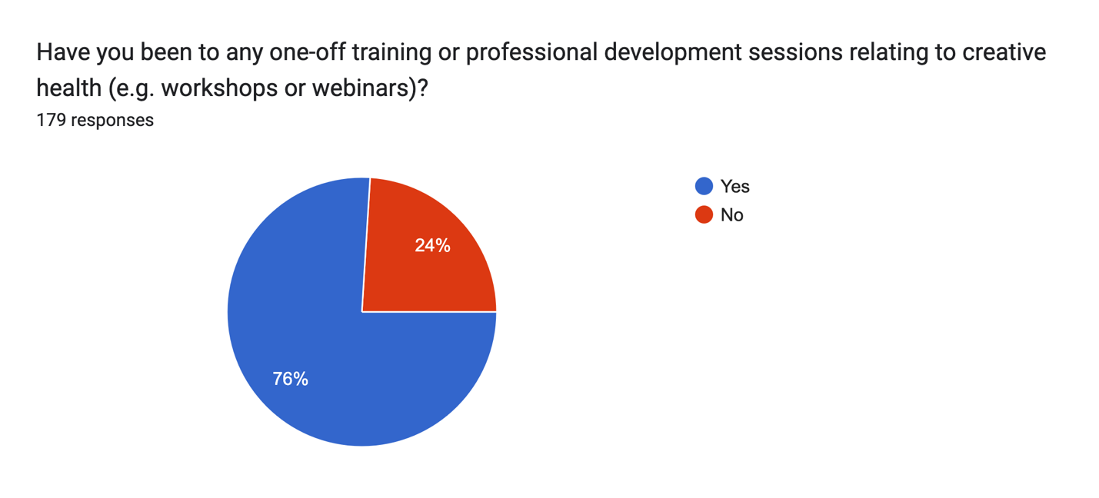
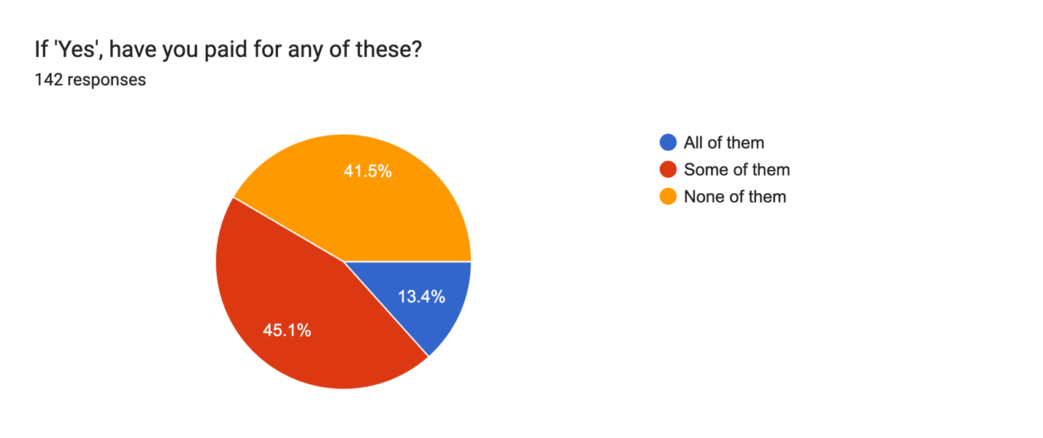
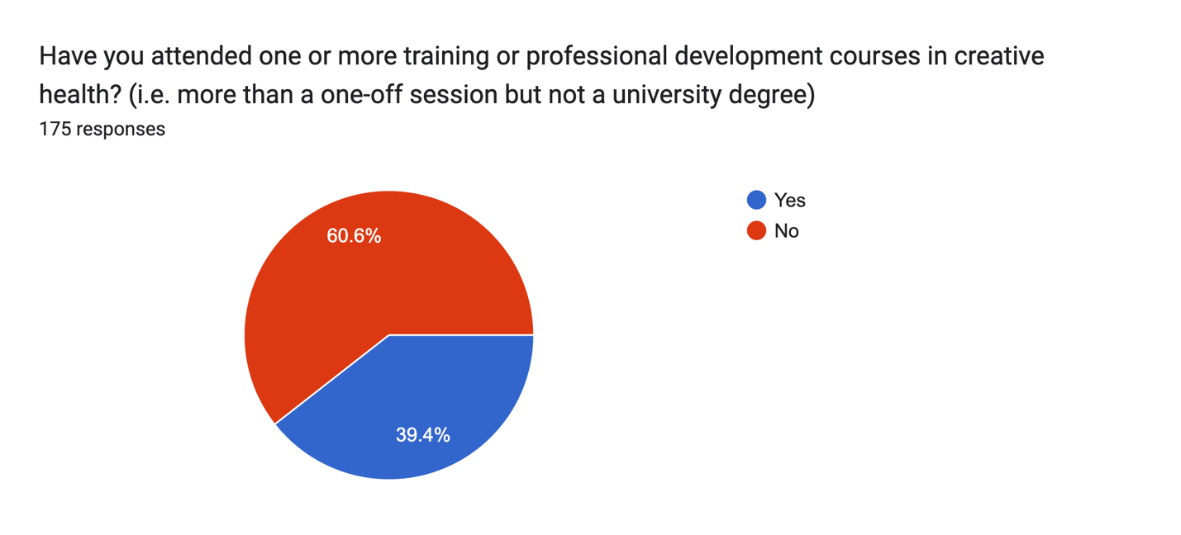
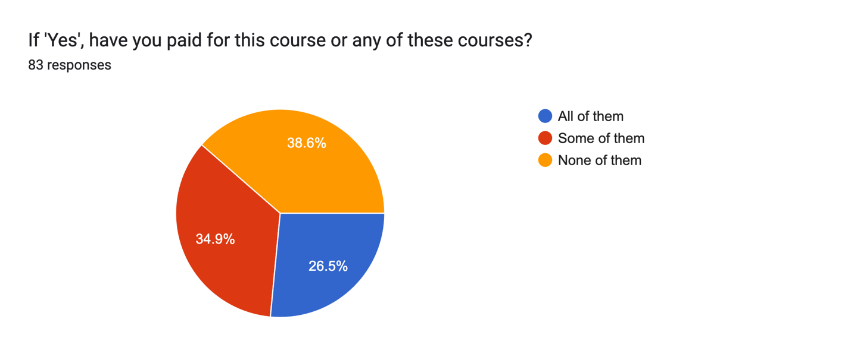
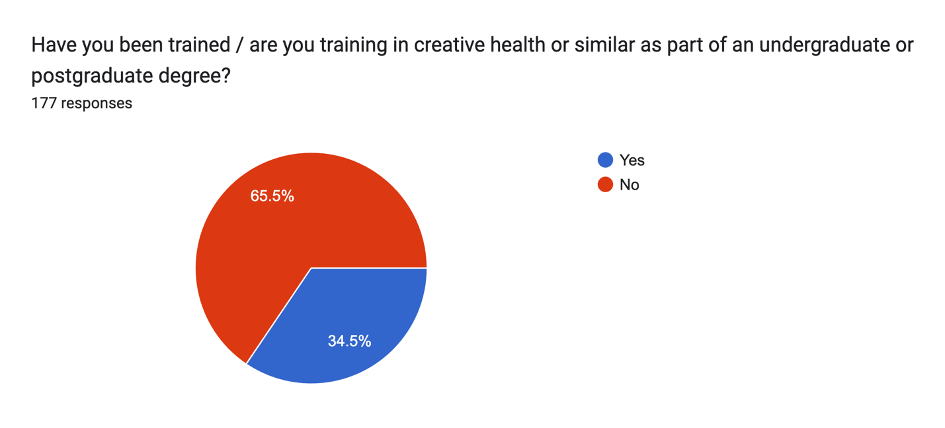
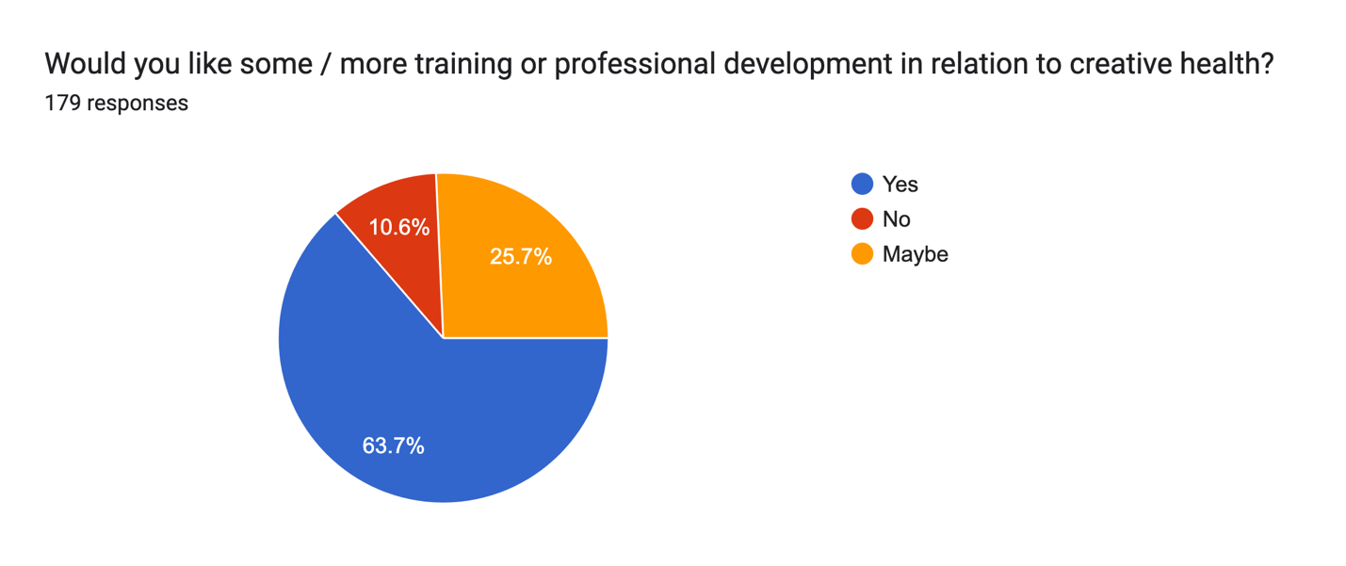
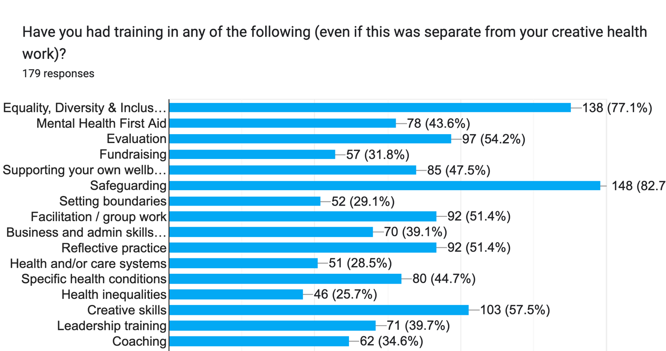

What training would people in the sector like to have?
AI overview (MS CoPilot)
“What would you like this training to focus on?”
The data reflects a very broad and mature Creative Health sector, with contributors ranging from early-career artists to senior leaders, commissioners, clinicians, and trainers. While interests are diverse, the responses cluster strongly around a core set of recurring themes.
Overall, the data shows demand for:
- Foundational training for artists entering Creative Health
- Advanced leadership and systems-change training for established practitioners
- Practical, applied learning that can be used immediately in real-world settings
- Emotional, ethical, and wellbeing support for those delivering the work

Key Thematic Areas

1. Creative Health Foundations & Sector Knowledge
A significant proportion of respondents want a stronger shared understanding of Creative Health as a field.
Common requests include:
- What Creative Health is and why it works
- National strategies, frameworks, and best practice
- Biochemical and physiological impacts of creative approaches
- The evolving research landscape
- How Creative Health fits into NHS, social care, and public health systems
- Creative Health in acute, community, and preventative settings
This reflects a desire to professionalise and legitimise Creative Health practice across sectors. [training r...r analysis | Excel]

2. Leadership, Management & Career Development
Leadership is one of the most frequently repeated themes in the dataset.
Requests span:
- Leadership development at early, mid, and senior career stages
- Leading Creative Health organisations (often described as “lonely” roles)
- Project and programme management
- Commissioning, systems change, and influencing policymakers
- Research leadership and strategic roles
- Business skills, governance, and sustainability
- “Train the trainer” and mentoring approaches
Many respondents explicitly mention the lack of tailored leadership training for Creative Health contexts. [training r...r analysis | Excel]

3. Working With Health & Care Systems
There is strong demand for practical understanding of health systems, especially from artists and creative practitioners.
Key needs include:
- How NHS and Adult Social Care systems work
- Roles and responsibilities in Health & Social Care
- Navigating commissioning and referrals
- Working effectively with clinical teams
- Legal literacy (Mental Health Act, safeguarding, professional boundaries)
- Understanding NHS priorities and unmet needs
This theme reflects a desire to collaborate more effectively and responsibly with healthcare partners. [training r...r analysis | Excel]

4. Facilitation, Safe Practice & Ethics
Many respondents focus on how to deliver work safely and inclusively.
Key areas:
- Group facilitation skills (including with reticent or mixed-need groups)
- Creating safer spaces indoors and outdoors
- Setting and maintaining boundaries
- Safeguarding (participants and staff)
- Managing attachment, trauma responses, and emotional risk
- Reflective practice and supervision
- When healthcare professionals should be involved
There is a strong emphasis on ethical clarity for artists who are not clinicians. [training r...r analysis | Excel]

5. Mental Health, Trauma & Specific Conditions
Respondents frequently request condition-specific understanding, particularly where creative practice may surface complex emotions.
Commonly cited areas:
- Neurodivergence
- Mental health (including men’s mental health)
- Trauma-informed practice
- PTSD
- Dementia
- Stroke rehabilitation
- Chronic pain
- Substance misuse
- Menopause
- Vulnerable adults and marginalised communities
Many want clear signposting and grounding tools, rather than clinical training. [training r...r analysis | Excel]

6. Equity, Diversity, Inclusion & Inequalities
EDI runs as a cross-cutting concern throughout the responses.
Key focuses:
- Health inequalities
- Anti-racist and equitable methodologies
- Working with marginalised communities
- Accessibility and adaptive tools
- Inclusive facilitation in changing political climates
- Culturally competent evaluation and engagement
This suggests EDI training is seen as core practice, not optional. [training r...r analysis | Excel]

7. Evaluation, Research & Impact
Another very strong theme is demonstrating impact.
Respondents want:
- Evaluation and measurement frameworks
- Creative and inclusive evaluation methods
- Storytelling and qualitative evidence
- Demonstrating impact to commissioners and funders
- Getting into research
- Bridging practice and evidence
Evaluation is positioned as essential for funding, advocacy, and system change. [training r...r analysis | Excel]

8. Funding, Sustainability & Access to Work
Practical sustainability concerns appear frequently.
Includes:
- Accessing funding and fundraising
- Budgeting for workshops
- Tax, freelance finance, and administration
- Networking and partnerships
- Finding health partners and referrals
- Career entry pathways into Arts & Health
- Advertising and audience development
- Supporting freelancers with training access
This reflects the precarity of Creative Health work and desire for more stable pathways. [training r...r analysis | Excel]

9. Practitioner Wellbeing & Peer Support
Respondents consistently acknowledge the emotional labour of Creative Health work.
Key needs:
- Avoiding burnout
- Supporting practitioner wellbeing
- Peer-to-peer support
- Reflective practice
- Being “held and facilitated” rather than always facilitating others
- Supervision and coaching
This suggests a need for training that supports the people delivering the work, not just the work itself. [training r...r analysis | Excel]

High-Level Insight
Taken together, the data shows a sector asking for:
- Clear professional standards
- Ethical clarity
- Stronger leadership pipelines
- Better integration with health systems
- Sustainable careers
- Care for practitioners as well as participants

