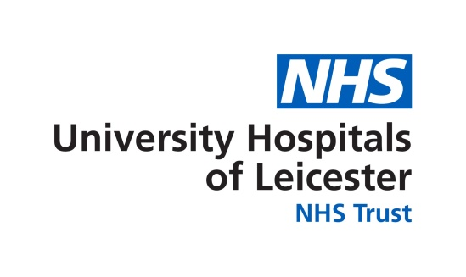
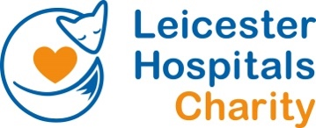
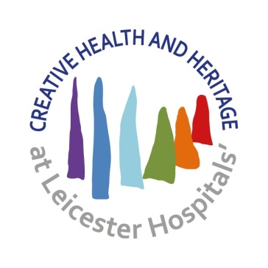
Celebrate National Creativity and Wellbeing Week 18 – 22 May 2026
Monday 18 May | Tuesday 19 May | Wednesday 20 May | Thursday 21 May | Friday 22 May
12.30 – 1.30pm  Creative Health & Heritage Centre, Glenfield Hospital  Creative Journaling workshop  Led by artist and wellbeing practitioner Sam Kitson  Explore different creative prompts and approaches to make a creative journal to support your daily wellbeing  https://buytickets.at/creativehealthheritageatuhl  /2179133 | 12.30 – 1.30pm  Creative Health & Heritage Centre, Glenfield Hospital  Blooming Crafting workshop  Relax and chat while  making flowers for our Bloom Creative Health Festival at the Riverside Festival  https://buytickets.at/creativehealthheritageatuhl  /2179229 | 12.30 – 1.30pm  Creative Health & Heritage Centre, Glenfield Hospital  ‘What is Creative Health, and what can it do for you?’  Talk by Sallie Varnam, Creative Health and Heritage Manager at UHL.  Find out about the benefits of Creative Health, the evidence base and the impact it can have on yours and your patients’ health and wellbeing.  https://buytickets.at/creativehealthheritageatuhl/2179271 | 12.30 – 2pm  Creative Health & Heritage Centre, Glenfield Hospital  Menopause Poetics workshop  This workshop will focus on sharing menopause experiences and developing creative writing responses to your own and others' testimonies. Open to anyone living with or who have lived through menopause. No previous writing experience necessary.  https://buytickets.at/creativehealthheritageatuhl/2179285 | 12.30 – 1.30pm  Creative Health & Heritage Centre, Glenfield Hospital  In Touch workshop  Led by post graduate researcher from the University of Leicester, Chris Jeavons  Learn how to practice mindfulness while exploring objects from UHL’s museum collection in this relaxing and engaging workshop suitable for all.  https://buytickets.at/creativehealthheritageatuhl/2179297

Monday 18 May | Tuesday 19 May | Weds 20 May | Thursday 21 May | Friday 22 May
7.30 – 8.30pm  Online  Empathy Hour workshop  Led by Dr. Helen Foster Explore how creative writing can foster empathy, understanding and emotional growth. With gentle guidance and inspiring prompts to spark your imagination, these workshops are ideal for healthcare professionals and students, educators, social workers, community practitioners and anyone interested in exploring the potential of creative writing to enrich their practice and perspective. No previous experience of creative writing is necessary.  https://buytickets.at/creativehealthheritageatuhl/2179309 | 6 – 7.30pm  Creative Health & Heritage Centre, Glenfield Hospital  Menopause Poetics workshop  Led by Dr. Helen Foster  This workshop will focus on sharing menopause experiences and developing creative writing responses to your own and others' testimonies. Open to anyone living with or who have lived through menopause. No previous writing experience necessary.  https://buytickets.at/creativehealthheritageatuhl/2179319 |  | 5 – 6pm  Creative Health & Heritage Centre, Glenfield Hospital  ‘What is Creative Health, and what can it do for you?’ talk  Talk by Sallie Varnam, Creative Health and Heritage Manager at UHL.  Find out about the benefits of Creative Health, the evidence base and the impact it can have on yours and your patients’ health and wellbeing.  https://buytickets.at/creativehealthheritageatuhl/2179327 | 2pm – 5pm  Creative Health & Heritage Centre, Glenfield Hospital  Blooming Crafting workshop  Relax and chat while  making flowers for our Bloom Creative Health Festival at the Riverside Festival  Drop in throughout the afternoon  https://buytickets.at/creativehealthheritageatuhl/2179330

Find the Creative Health & Heritage Centre behind the Mansion House at Glenfield Hospital, use What3Words: allow//closer//method
All events are free, refreshments available to buy, please bring cash. Donations gratefully received to cover costs of materials and support our fundraising for the Creative Health & Heritage Centre.
See the national Creativity and Wellbeing Week programme here

