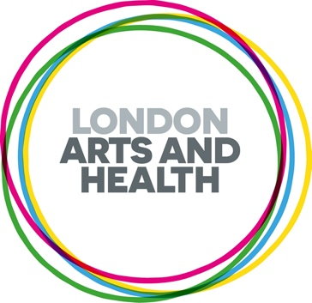
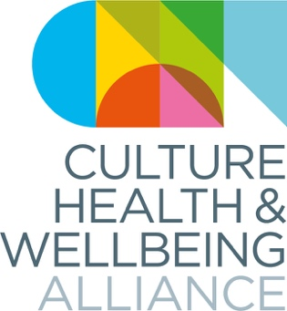

'Honouring Our Communities’ Pitches for Black History Month 2026
Culture, Health and Wellbeing Alliance (CHWA) and London Arts and Health (LAH) are pleased to be collaborating on a paid callout for ethnically diverse creative health artists/practitioners for Black History Month 2026. The theme for this year is ‘Honouring Our Communities,’ which invites us to look more closely at something often taken for granted — the people holding Black communities together, in relationships, in support systems, and in the spaces where people find belonging. It asks us to consider whose work we value, whose stories we tell, and whose contributions we may have overlooked.

We are focusing on artists within Black communities across the UK who are being recognised as changemakers within the realm of creative health and social justice, whose contributions are central to the continued resilience, progress and identity of Black communities. Selected blogs will be featured through the CHWA bulletin and LAH newsletter, website and social media channels from mid to late October 2026. Each selected piece will receive a fee of £150.
Prior to completing this form, please read or listen to the full call out brief on our website.
Please note we invite people who have personal or professional experience in relation to this theme. Please respect this held space and do not apply if you don’t fit this criteria.
Please get in touch if we can support you in the process of applying or if you have any other questions at Kheyla@culturehealthandwellbeing.org.uk and/or info@londonartsandhealth.org.uk (we aim to get back to you within a week of sending an email).
Deadline: Wednesday 30th September 5pm

Full Name
Gender
Preferred Pronouns
Email Address
Where in the UK are you based?
Describe your creative practice and thematic projects in 200 words
Please note pitches must be pertaining to creative health and respond in some way to the theme of ‘Standing Firm in Power and Pride’. Creative health can be any creative approaches and activities which have benefits for our health and wellbeing.'
Which best describes your idea (please pick one) | A written blog, creative reflection or case story
Please use this space to add any additional information you might want to share with us

e.g. website, online portfolio, social media, image, video or audio, jpg, YouTube

Please tell us your personal or professional interest in submitting for this callout/contributing on this theme

Thank you for taking the time to apply to this call out. Please return this form, along with a copy of your CV, to Kheyla@culturehealthandwellbeing.org.uk and info@londonartsandhealth.org.uk by Wednesday 30th September at 5pm.

If you feel comfortable doing so, please fill our EDI questionnaire by following the link below. This helps us to understand more about and improve equity in creative health.

https://forms.gle/yxVaRrb1yUesb1VeA

