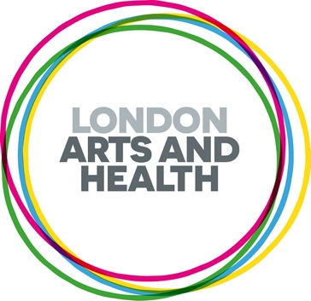
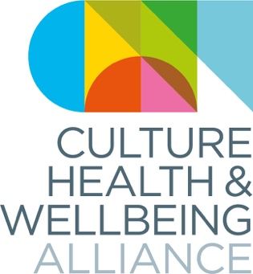

'Standing Firm in Power and Pride’ Pitches for Black History Month 2025
Culture, Health and Wellbeing Alliance (CHWA) and London Arts and Health (LAH) are pleased to be collaborating on a paid callout for ethnically diverse creative health artists/practitioners for Black History Month 2025. The theme for this year is ‘Standing Firm in Power and Pride,’ and we are interested in work that is rooted in the belief that the arts can be a powerful force for health, climate justice, and cultural empowerment. In tribute to the resilience, strength, and unwavering commitment to progress that defines the Black community, we want to highlight the work of artists within black communities across the UK who are being recognised as leaders, activists, or pioneers within the realm of creative health, climate action and planetary health, honing in on community initiatives. Selected pieces will be featured through the CHWA bulletin and LAH newsletter, website and social media channels throughout October 2025. Each selected piece will receive a fee of £150.
Prior to completing this form, please read or listen to the full call out brief on our website.
Please note we invite people who have personal or professional experience in relation to this theme. Please respect this held space and do not apply if you don’t fit this criteria.

Please get in touch if we can support you in the process of applying or if you have any other questions at Kheyla@culturehealthandwellbeing.org.uk and/or Drashti@londonartsandhealth.org.uk (we aim to get back to you within a week of sending an email).
Deadline: Monday 8th September 5pm

Full Name
Gender
Preferred Pronouns
Email Address
Where in the UK are you based?
Describe your creative practice and thematic projects in 200 words
Please note pitches must be pertaining to creative health and respond in some way to the theme of ‘Standing Firm in Power and Pride’. Creative health can be any creative approaches and activities which have benefits for our health and wellbeing.'
Which best describes your idea (please pick one) | A blog, a creative reflection, a case story  A short video on their practice/work  A written project description along with their portfolio
Please use this space to add any additional information you might want to share with us

e.g. website, online portfolio, social media, image, video or audio, jpg, YouTube

Please tell us your personal or professional interest in submitting for this callout/contributing on this theme

Thank you for taking the time to apply to this call out. Please return this form, along with a copy of your CV, to Kheyla@culturehealthandwellbeing.org.uk and Drashti@londonartsandhealth.org.uk by Monday 8th September at 5pm.

If you feel comfortable doing so, please fill our EDI questionnaire by following the link below. This helps us to understand more about and improve equity in creative health.

https://forms.gle/soxyXjexiZxk7EyK9

