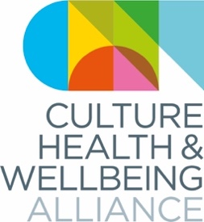
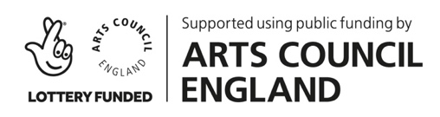
A Culture of Care: Culture, Health & Wellbeing Alliance national conference 2020

Derby Museum, 19-20 March 2020

#CHWA2020 (Please note we will be adding to the programme until nearer the date of the conference and may make minor changes to timings or content)

 | THURSDAY 19 MARCH |  |  |  | FRIDAY 20 MARCH
0900-0930 |  |  |  |  | Registration  including a Slow Stitching Workshop from Common Threads
0930-1000
1000-1030 | Registration plus… guests tbc. |  |  |  | 10:00-10:15 Provocation: Clive Parkinson, Arts for Health, Manchester MMU and the Manchester Institute for Arts, Health & Social Change
1030-1100 |  |  |  |  | 10:15-11:30 Panel 3: Health Inequalities 10 years after the Marmot Review. What’s culture got to do with it?  Joy Francis, Synergi/ Words of Colour | Lord Howarth of Newport | Gregor Henderson, Public Health England | Esme Ward, Manchester Museums/CHWA | Helen Chatterjee, UCL/CHWA (Chair)
1100-1130 | Introduction: Victoria Hume & Hayley Youell, CHWA | Tony Butler, Derby Museums | Alex Coulter, Arts & Health South West/ CHWA
1130-1200 | Panel 1: Climate  Zena Edwards, poet/ arts activist | Alistair Gentry, Unlimited | Dr Guddi Singh, paediatrician/ health campaigner/ TV broadcaster | Hilary Jennings, Happy Museum (Chair) |  |  |  | Tea break
1200-1230 |  |  |  |  | Panel 4: Caring Economies  John McMahon, Arts Council England (Chair) | Mah Rana, artist/ researcher/ writer/ curator / LENS champion | Ian Solomon-Kawall, May Project Gardens | David Cutler, Baring Foundation | Trishna Nath, Nesta
1230-1300 | Lunch
1300-1330 |  |  |  |  | Lunch:  Including networking by geography
1330-1400 | At QUAD: The Politics of Care. Exhibitions, VR sessions and film  screening of Alongside by Dryden Goodwin, plus discussion with Jane Hardstaff, QUAD | Paul Johnstone, carer & musician | Andrew Williams, Level Centre | Brian Walsh OBE, Campbell Village Trust | Abbie Canning, Q Club Curator| | At Air Arts (Derby Teaching Hospitals): A Breath of Fresh Air  Exhibition tour: Wellbeing in the Workplace, with insights from staff artists  Workshops: Experiential dance workshop and an object handling session with items from the hospital’s medical museum | At Baby People: What difference does the genre make? Baby J, Baby People | Mark Prest, Portraits of Recovery | Damian Hebron, NESTA [& more tbc] | At Derby Museums: The creative arts therapies & culture/arts in health and wellbeing  Prof Susan Hogan, University of Derby | Jennifer Stokes, Reside Dance CIC with Emma Dickson, Dance artist and movement psychotherapist [& more tbc]
1400-1430 |  |  |  |  | Facilitated discussions around the museum:  What’s next for Money, Love and Nature?
1430-1500
1500-1530
1530-1600 | Tea break |  |  |  | Facilitators report back
1600-1630 | Panel 2: Practitioner Support  Thanh Sinden, Museum Detox/CHWA | Nicola Naismith, artist/researcher (Chair) | Daniel Regan, Freespace Gallery/Arts & Health Hub | Deborah Munt, Ministry of Others/Arts Derbyshire | Sara Bains, Public Health Derbyshire |  |  |  | Closing Performance: Sinfonia Viva Carers' Choir
1630-1700 |  |  |  |  | 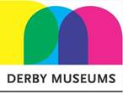  Thank you to all our conference partners
1700-1730
1730-1800 | Break…. Optional exhibitions at QUAD (Self-portrait) and Derby Museum
1800-1830
1830-1900 | Drinks & Dinner, including:  Performance: Baby People: The Melisma Choir and Special Guests and the CHWA Awards ceremony hosted by Lord Howarth of Newport
1900-1930
1930-2000
2000-2030

