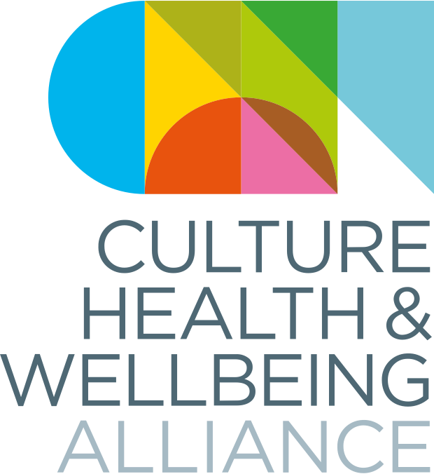

Making Change National Conference
11 – 13 October 2023
The Culture, Health & Wellbeing Alliance

Pre-Conference Resource Pack

Welcome

The Culture, Health & Wellbeing Alliance (CHWA) are thrilled to be hosting another in person national conference in October, and to have secured such a wide variety of speakers who all come to creative health from a variety of disciplines, roles and industries, and with a range of skills and experiences.

We have designed a pre-conference pack to highlight some articles, interviews, reports and information which you might find interesting ahead of the event. We have also worked with Heart of England Community Rail Partnership and artist Emma Kaye Illustration to provide some creative exercises specifically to help with travel related anxiety, which you can find on the next page.

We hope you enjoy your time at #CHWAConference2023, and do let the team know if there’s anything you need.

Many Thanks,

The CHWA Team

Heart of England Community Rail Partnership
DO

We know that your experience of the conference starts long before you get to the venue. We hope our slow start on Wednesday will give you plenty of time to travel and arrive well and ready to absorb the event.

We know that for some people, travel and public transport can be a source of anxiety, therefore we have partnered with Heart of England Community Rail Partnership and Emily Kaye Illustration to adapt their Creative Platforms programme for conference attendees. This includes a downloadable activity pack and a series of video tutorials all designed to promote mental wellbeing whilst travelling. We hope you find it fun and useful!

Our Earth, Your Choice

Winner of the CHWA Climate Award 2022, Our Earth, Your Choice is an original video game in response to the climate crisis, co-produced and built with 25 children and young people in Wakefield, South Yorkshire. Read more about the process and download the game on their website.
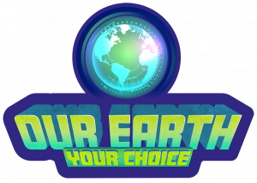

The Creative Health Quality Framework
READ

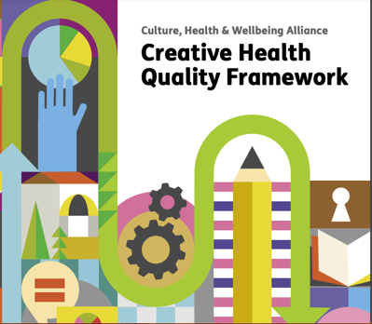
The Creative Health Quality Framework, launched by the Culture, Health & Wellbeing Alliance in September 2023, is a ground-breaking tool that clearly articulates what “good” looks like for creative and cultural initiatives that aim to support people’s health and wellbeing.

Read and download the full document, including
Posters and resource pack, on the CHWA website

UK Creative Health: the state of the sector Survey

CHWA has recently published the response to their 2023 Creative Health survey, analyzing the experience and feedback of 200 creative health workers. You can find a brief summary of the findings on the CHWA website.

Creatively Minded & Refugees Report (20 June 2023)
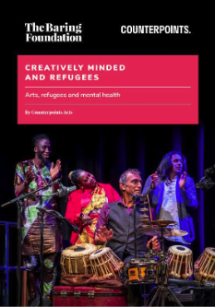
The Baring Foundation and Counterpoint Arts
have produced a report showcasing the work of 12
organisations who offer creative opportunities, across
a range of artforms, and support to refugees and
people seeking asylum. You can read the report on
the Baring Foundation website.

Greater Manchester launches its first annual Recoverist Month
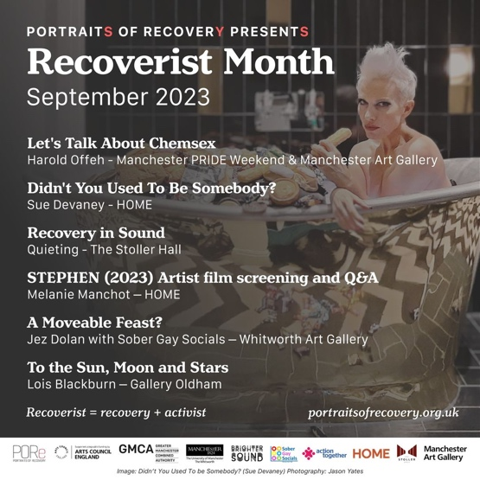
Recoverist Month puts Greater Manchester’s
thriving recovery communities centre stage by
increasing visibility and directly supporting the voice of lived experience. Celebrating recovery from substance use through the arts and culture, the event promotes positive health messages and adds to the conversation that recovery is a viable lifestyle choice. More information can be found here.

Queering Creative Health Report

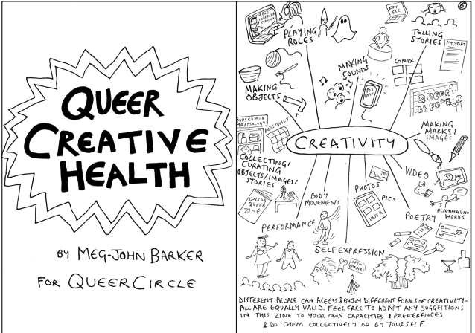
Our friends at QUEERCIRCLE, alongside UCL, have published ‘Queering Creative Health;’ a community-informed evaluation of QUEERCIRCLE’s health and wellbeing programme. The report, and accompanying zine, explore how creative health projects work within LGBTQ+ contexts, and makes the case for a community informed approach to health.

Frances Williams, Health & Research Lead at QUEERCIRCLE, will be speaking as part of the first conference panel.

LISTEN
Radio Arts Cataylst – Changing Currents Podcast
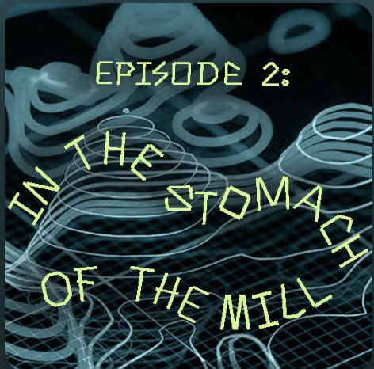
Changing Currents is a new podcast series exploring climate perspectives and possible futures featuring the voices of artists, growers, activists, local community groups, heritage workers and researchers across South Yorkshire. In this episode, listen to CHWA National Coordinator Hayley Youell discuss remediation, resourcefulness and ecological health. Listen here.

Arts & Health South West Podcast
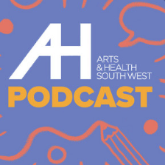
Reflections on practice in the creative health sector
from Arts & Health South West. Conversations with
practitioners from theatre, creative writing, music
and more. Listen here.

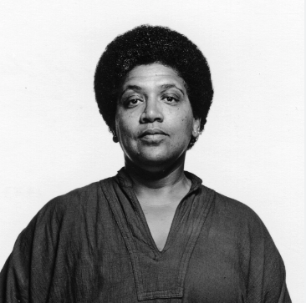
Angela David on Audre Lorde

“Unity does not require us to be identical to
one another”

https://tinyurl.com/yvf47kmr
WATCH

