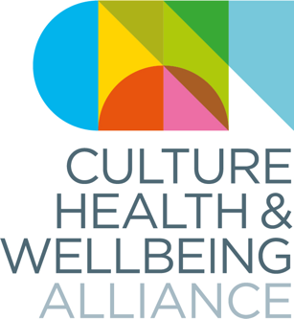
CHWA Conference 2023: South Yorkshire

Bursary Opportunity - deadline 11 September

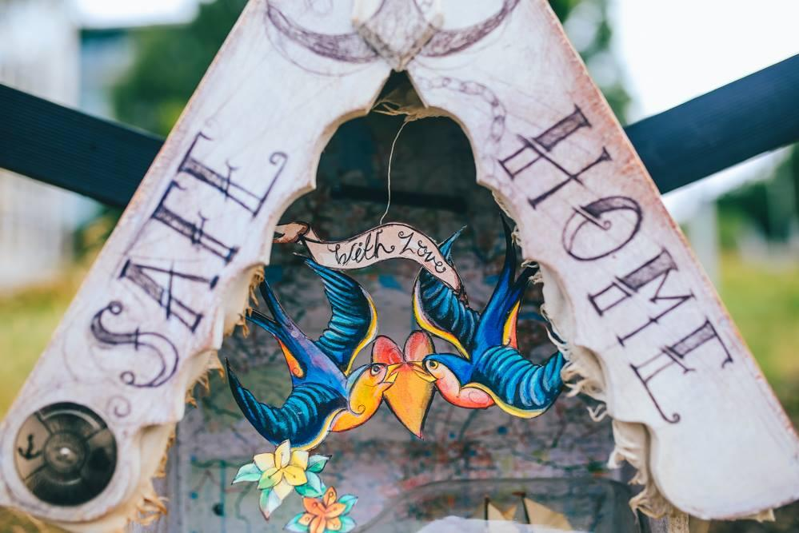
An opportunity to support freelance creative practitioners based in South Yorkshire to attend Making Change, the Culture, Health & Wellbeing Alliance national conference.
Conference Dates: 11-13 October 2023
Venue: Various, Barnsley Town Centre
Through generous support from the South Yorkshire Mayoral Combined Authority, the Culture, Health & Wellbeing Alliance is offering 10 free spaces to attend Making Change: Culture, Health & Wellbeing Alliance national conference to freelance creative practitioners who live, or whose practice, is based in the South Yorkshire Region. We particularly want to encourage applications from people identifying with any of the protected characteristics as defined in the 2010 Equality Act, or who are from less affluent socioeconomic backgrounds.

Each bursary recipient will receive:
- One free ticket to the conference, taking place in Barnsley from 11-13 October
- A £100 stipend - this can be used for whatever the practitioner needs - for example travel, accommodation, or to cover their time
- Food and refreshments whilst at the conference

Please note if you have access needs where attendance will incur additional charges do let us know as CHWA has a budget to support this.

Important Information and Key Dates
Please Apply here by Monday 11 September at 5pm.
If you prefer, you can also send an audio or video file to fiona@culturehealthandwellbeing.org.uk
All applicants will be contacted by Monday 18th September.

Accessibility is important to us
Find out more about how we are striving to improve our access on our access page
You can also listen to this callout or download a PDF or Word version.
Close for submissions: 5pm, Monday 11th September

Please get in touch if we can support you in the process of applying, or if you have any other questions at fiona@culturehealthandwellbeing.org.uk . We aim to get back to you within a week of sending an enquiry.

Name: _________________________________
Preferred Pronoun: ____________________
Email Address: _________________________
Role/Occupation:_______________________

What area are you based in (either living or working)
_________________________________
Tell us about yourself and the kind of work you make:

Why do you want to attend Making Change? How will it benefit your work as a creative professional? (200 words max.)

Please give us up to three links to your work, if relevant

Please tell us which days you would like to attend the conference (you can attend as many days as you wish)
Weds 11th October
Thurs 12th October
Fri 13th October
Please let us know if you have any access requirements, including BSL interpretation needs

For more information on what we are doing to make the conference more accessible see https://culturehealthandwellbeing.org.uk/access-chwa-conference-2023

Please email this completed form to fiona@culturehealthandwellbeing.org.uk

