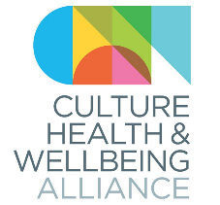
Expenses Claim form
Culture Health & Wellbeing Alliance

Name:
Address:
Email Address:
Phone Number:

Expenses to be reimbursed (please type details in the table below)
- Rail travel should be standard class and travellers should take advantage of cheap day or reduced fares, if available. Mileage should be calculated at a rate of 40p per mile.

- CHWA will refund a maximum travel expenses claim of £100 per person. Claims above this level need pre-authorisation from the Director of Culture Health & Wellbeing Alliance.

Date  (date on receipt) | Description of expense (e.g. ‘return train journey from Leeds to London Euston for Board meeting’) | Amount spent
TOTAL AMOUNT TO BE REPAID

I certify that the expenses claimed on this form are correct and have been incurred during the course of work relating to Culture Health & Wellbeing Alliance.

Signature of claimant |  | Date

Expenses should be paid into the following bank account (please complete details below):

Account holder name:
Account number:
Sort Code:
Please save your completed form, and attach digital copies (photos or PDFs) of any receipts and email these to Sarah Holmes at finance@culturehealthandwellbeing.org.uk

