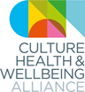 CHWA 2021 AWARDS
Although the world and life as we know it has changed since we launched the CHWA 2020 Awards in the winter of 2019, we and our partners believe that the themes of collective power (partnership), practitioner wellbeing and climate are ever more relevant and important. We also recognize that we cannot go forward without addressing the connections between our work and health and cultural inequalities – and specifically the impacts of racism.
During the pandemic, we have seen the culture, health and wellbeing sector respond with creativity, imagination and kindness to meet global crisis, local need and individual loss. As partnership and collaboration have driven innovation and greater reach, the need to systematically support wellbeing across the sector, and to respond to the climate and ecological emergency and its relationship with global and local inequalities is becoming clearer.
We are looking for projects, organisations and people who have led the way through lockdown and/or are learning from this challenging time to build a better future. We want to hear about work of all types and reach.

Collective Power Award in partnership with Ideas Alliance and The LENs (Lived Experience Network)
Together we are stronger.
In collaboration with the Ideas Alliance and The LENs this award aims to recognise an inspiring project, consortium, collective or movement of people in which meaningful partnership and co-production has improved the health and wellbeing of individuals and communities through culture and creativity.
We are keen to hear about all scales of collaboration: from small grassroots initiatives and emerging virtual communities to sector-wide consortiums. Your work may address the specific wellbeing needs of local residents in a street, or challenge limiting societal beliefs or inequalities experienced by communities of people.
Submissions must involve culture, creativity or the arts, and they must engage with health, care or wellbeing; but the partnership may also involve organisations or individuals engaged with activism, education, social justice or any other relevant sectors to bring about change.

Working together with The LENs, we are increasing our focus on co-production and lived experience. We are particularly interested in examples where co-production is embedded in planning, design and delivery.
We are also interested in the impacts, positive and negative, the pandemic has had on our capacity to build and sustain partnership.
We invite all types of groups and collectives to apply. You do not need to be a constituted group, legal entity or established organisation. The key is meaningful partnerships and collaboration bringing together different fields of practice and lived experience.
As part of this award, all shortlisted projects will be showcased nationally by the Ideas Alliance on their online Ideas Hub. Check out the Collective Power Shortlist 2020 blogs here.
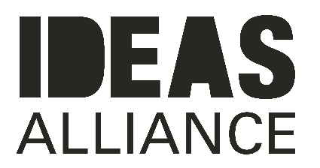

The Ideas Alliance is a social enterprise that promotes the benefits of collaborative and strengths-based and community driven approaches. We deliver projects and training with councils, charities and local organisations supporting them to engage collaboratively with local people, co-design services and find solutions to social issues. We use collaborative and storytelling methods to find out what matters to people, helping to connect data to real emotion that uncovers powerful perspectives and evidence to drive positive change locally.

Since our inception in 2017, we have engaged with over 6,500 people through different projects with organisations across the country and we have published over 300 articles via the Ideas Hub, our online space for publishing case studies, interviews, blogs and reports about people getting on and making things happen.
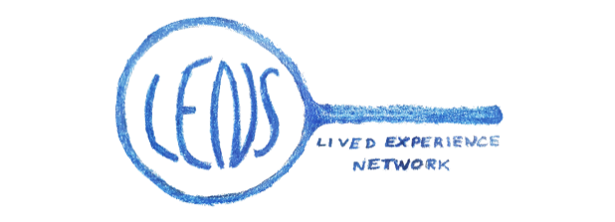
The LENs is a network of people who believe in the benefits of creative and cultural engagement to individual and collective wellbeing.

By working in partnership and acting as a critical friend, The LENs will champion access to creative and cultural opportunities for all.
The LENs will work to ensure that the voices of those with lived experience remain at the heart of the arts, health and wellbeing movement.
Notes for Applicants:
- We can accept applications in different formats. Please do contact the CHWA Awards Team at awards@culturehealthandwellbeing.org.uk and we can support you in this process.
- Projects or programmes need to be based in the UK and we can only accept one application per organisation per award.
- At least some of the project / programme needs to have taken place since March 2020 and the national lockdown but we are delighted to accept work that began before and has had to adapt or work that was developed directly in response to the lockdown
- Projects or programmes can be ongoing but need to be able to demonstrate impact or change.
- There is no cash prize but the awards will be widely publicized via CHWA and our partners’ websites and networks and are an opportunity to showcase your work nationally.

Important Dates for Applicants:
Submission deadline is 5pm, Friday 12 February. Please email this form to awards@culturehealthandwellbeing.org.uk
Shortlisted applicants will be contacted by the Alliance soon after and their projects published on the CHWA website.
Winners will be announced at an open online event as part of the CHWA 2021 Conference: A Culture of Care on Friday 23 April 2021.

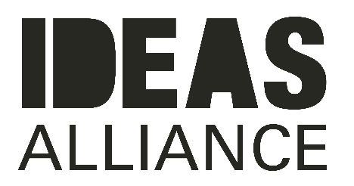
COLLECTIVE POWER AWARD Application Form
Name
Email
Contact Number
Project Name
Project website or links to supporting media (3 maximum including website/images/film)

Where is/was the project based?

When did the project start and end (or is it ongoing)?

Your relationship to the project

Please list all partners/collaborators/instigators

Please list any funders for this project

The Project
General project description (150 words max)

What instigated this work, and how has the project responded to the pandemic? (150 words)

How does this project represent collective power? (150 words)

The People
Did you involve people with relevant lived experience in the design and delivery of this work? If so, how? (150 words max)

Impact
What have been its impacts so far? Please give us any stats associated (evaluation statistics, numbers taking part etc.) and/or share any stories, quotes or case studies (200 words max)

Other
Is there anything else you want to tell us about the project/people involved? (200 words max)

