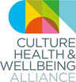 CHWA 2021 AWARDS
Although the world and life as we know it has changed since we launched the CHWA 2020 Awards in the winter of 2019, we and our partners believe that the themes of collective power (partnership), practitioner wellbeing and climate are ever more relevant and important. We also recognize that we cannot go forward without addressing the connections between our work and health and cultural inequalities – and specifically the impacts of racism.
During the pandemic, we have seen the culture, health and wellbeing sector respond with creativity, imagination and kindness to meet global crisis, local need and individual loss. As partnership and collaboration have driven innovation and greater reach, the need to systematically support wellbeing across the sector, and to respond to the climate and ecological emergency and its relationship with global and local inequalities is becoming clearer.
We are looking for projects, organisations and people who have led the way through lockdown and/or are learning from this challenging time to build a better future. We want to hear about work of all types and reach.
Climate Award in partnership with The Happy Museum Project and Culture Declares Emergency
In 2020, the world has faced the realities of three emergencies which threaten the wellbeing of people, place and planet. A global pandemic that has revealed growing global and local inequalities – including the impacts of racism on our health as a society and as individuals – and a climate and ecological emergency. These cannot be seen as separate concerns. Health, inequality and climate are interwoven consequences of how we as humans treat each other and the world around us.
Joining forces with The Happy Museum Project and Culture Declares Emergency, we want to shine a light on the people and projects using creativity and culture to address these challenges.
We are looking for projects/organisations that are recognising the connections between climate, health inequalities and creativity/culture. Submissions could include projects that link mental health, climate justice and creativity, for example, or connect nature, culture and wellbeing. They might be about building “safe and brave places”, grassroots movements, internal campaigns that are raising awareness, or organisations instigating systemic changes in approaches to procurement, commissioning and selection of work and resources. These are just suggestions and we are happy to be surprised and delighted by practice we had never considered.

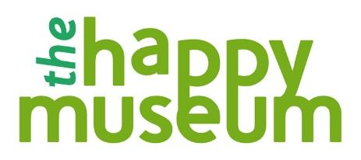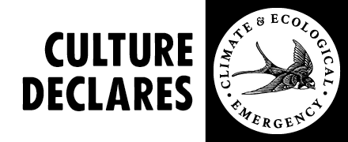

Notes for Applicants:
- We can accept applications in different formats. Please do contact the CHWA Awards Team at awards@culturehealthandwellbeing.org.uk and we can support you in this process.
- Projects or programmes need to be based in the UK and we can only accept one application per organisation per award.
- At least some of the project / programme needs to have taken place since March 2020 and the national lockdown but we are delighted to accept work that began before and has had to adapt or work that was developed directly in response to the lockdown
- Projects or programmes can be ongoing but need to be able to demonstrate impact or change.
- There is no cash prize but the awards will be widely publicized via CHWA and our partners’ websites and networks and are an opportunity to showcase your work nationally.
Important Dates for Applicants:
Submission deadline is 5pm, Friday 12 February. Please email this form to awards@culturehealthandwellbeing.org.uk
Shortlisted applicants will be contacted by the Alliance soon after and their projects published on the CHWA website.
Winners will be announced at an open online event as part of the CHWA 2021 Conference: A Culture of Care on Friday 23 April 2021.

.
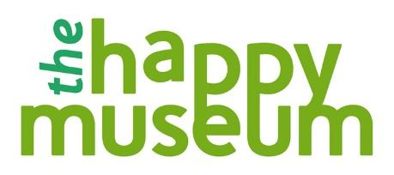
CLIMATE AWARD
Application Form
Name
Email
Contact Number
Project Name
Project website or links to supporting media*

Where is/was the project based?

When did the project start and end (or is it ongoing)?

Your relationship to the project

Project Funders

The Project
General project description (150 words max)

We are interested in work that joins the dots between health and wellbeing, climate, and creativity/culture. How does your work use creativity/culture to enable the health and wellbeing of people, place and planet? (200 words)

In what ways have you involved people with relevant lived experiences of environmental challenges? (150 words max)

The Impact
(If you have any evaluation statistics, numbers taking part etc, please share them here, along with any stories, quotes or case studies)
What are the health or wellbeing impacts? (150 words max)

What are the impacts for the environment, or places and planet? (150 words max)

Other
Is there anything else you want to tell us about the project/people involved? (200 words max)

*Please send us a maximum of 3 supporting links to any images, recordings, blogs/evaluations or films associated with the project you would like to share.

