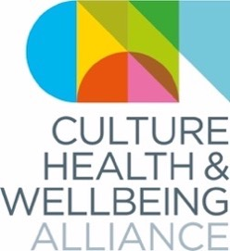

Culture, Health and Wellbeing Alliance CIC

Sector Support Organisation

Business Plan & Budget 2021-22

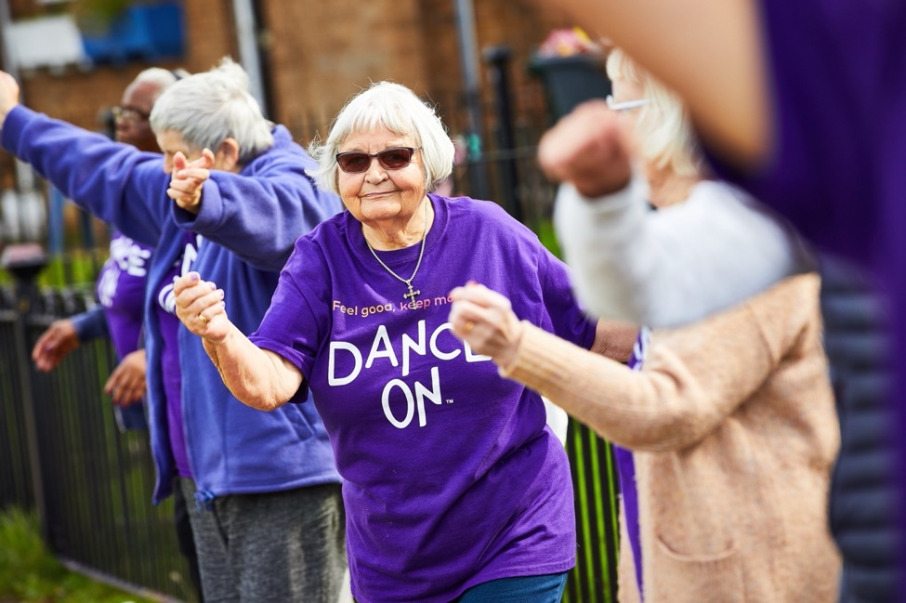
Image credit: Yorkshire Dance

Index
1. Executive Summary 3
2. Background 4
Vision, Mission and Principles 4
The Alliance 5
Strategic Priorities 7
3. ACE Investment Principles 8
Our commitment 8
Existing work 9
Outline of evidence and data sets we will use 9
Dedicated time with the board and staff to embed the Investment Principles 12
4. 2021-22 Business Plan 13
Activity Plan 2021-22 14
Activity Plan 2021-22 (detail) 15
Equality Action Plan / Developing membership 15
Mapping & research 18
Events & Annual Awards 19
Partnerships 20
1. Ongoing work 22
Fundraising 23
Staff roadmap 24
Communications 25
Evaluation 26
2. Budget 27

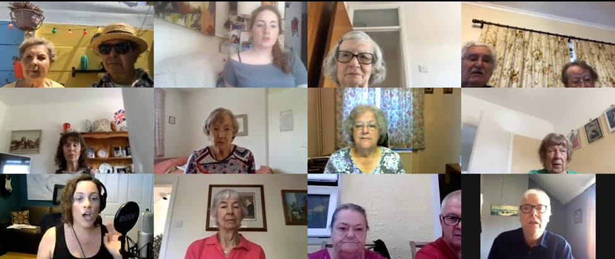
rb&hArts: Singing for Breathing session on Zoom with Elisa Jeffery

Executive Summary

There are now thousands of practitioners and organisations working at intersection of culture, health and wellbeing. Whilst they are disparate in their approach, this is generally challenging and complex work, carried out by passionate people working in an uncertain landscape, during worsening inequalities.

There are huge opportunities presented by the Social Prescribing and Tackling Loneliness agendas, the rapidly improving evidence base, and the increased awareness covid has fostered of the impacts of creative and cultural practice.

Our role as the Culture, Health & Wellbeing Alliance (CHWA) is vital for those working in culture, health and wellbeing to navigate these challenges and opportunities, to collaborate, learn and develop.

CHWA gives this diverse sector a collective voice, amplifying our members’ work and its impact, and thereby supporting its sustainability. Our membership has tripled since August 2018, from 1,800 to almost 6000 and our key stakeholder networks include regional champions around the country, over 50 national delivery organisations (Strategic Alliance Members) and our Strategic Partners: Arts Council England, the National Lottery Heritage Fund, Public Health England, NHS England and the Local Government Association. We work with our general members to produce mapping, reports and recommendations for policymakers and funders – helping clarify the barriers and enablers for this work, from skills development and research to investment. We are a hub for up-to-date information on policy developments, research and best practice for the sector, and manage localised networks and peer support around the country. We work to maintain vital conversations across national, strategic, and grassroots organisations so that practice can evolve and spread across the country.

We are analysing and developing the ways in which our membership and key stakeholder groups work, to ensure we are better able to represent organisations and individuals who have been historically marginalised from both the health and the cultural sectors (see our Equality Action Plan, below).

CHWA was founded in 2018 as a merger of two pre-existing national organisations, the National Alliance for Arts, Health & Wellbeing and the National Alliance for Museums, Health & Wellbeing. The new organisation was funded as part of an NPO bid for 2018-22 from Arts & Health South West, who provided support to the organisation until its formation as a CIC with a new Board of Directors in December 2019 and its formal novation in December 2020.

Our Business Plan for 2021-22 is built on three years’ experience of developing this Alliance and responds, too, to the impacts on the sector and rapid social changes ushered in by the pandemic, as well as the increasing urgency of addressing the twin crises of inequalities and climate change.

It has been apparent throughout the pandemic and lockdowns that the work of the organisations and individuals we support – tackling loneliness, supporting mental health and community cohesion, and ensuring cultural access for all – has never been needed more, and CHWA’s capacity to meet demand for support across the sector has been challenged more than ever in 2020.

We anticipate that 2021-22 will be a year of growth for CHWA during which a number of work programmes will bear fruit, and we will work on building core capacity for a more sustainable model.

Background

Vision, Mission and Principles

Our vision
A healthy world powered by our creativity and imagination

Our mission
We are an organisation driven by the collective power of our members. We connect, amplify and support their work to transform people's lives and communities through culture and creativity.

We are
- Collaborative
- Generous
- Representative
- Committed to social change
We connect
- Regional champions and networks around the country
- Partnerships across culture, health, social care, local govt
- Practice and research
We amplify
- Listening and learning
- Highlighting best practice
- Leadership and advocacy
We support
- Information
- Training & peer learning
- Coproduction
We are people-powered. Join us.

The Alliance
CHWA brings together a number of intersecting groups. (Those pictured below outside the ‘membership’ circle are independent partners.)
CHWA membership
CHWA has a membership of 5,500. Membership is currently free. Members receive a monthly bulletin and are also connected into the organisation via regional champions, below. Members inform our strategic priorities, and their work is represented across our website and our bulletin, and in evidence we gather to share with strategic partners. They participate in our national programme, as well as regional networks and regional support. Members are also able to stand to become regional champions or join regional steering groups where these have been formed. For more details see Developing membership offer, below.
Regional champions
We manage 18 volunteer champions; two in each of the nine English regions. The champions broadly follow a co-produced Guide which encourages them to Explore | Connect | Advocate | Develop. Activity varies region to region according to regional priorities and the champions’ capacity.
The LENs
The LENs (Lived Experience Network) is a network of people with lived experience of the impacts of creativity and culture on their own health and wellbeing, who believe in the benefits of creative and cultural engagement to individual and collective wellbeing. The LENs acts as a critical friend to CHWA and the National Centre for Creative Health (see below).
CHWA has supported the organisational development of the LENs since our own inception – including hosting their information on our site, and providing administrative support for the Steering Group of regional LENs champions, who also ‘buddy’ with CHWA regional champions to support local network development and events. We co-present at national and local events. CHWA has supported the LENs’ process towards becoming an independent CIC in 2021, including the appointment of new Directors. The LENs sends an observer to all CHWA Board meetings.

The National Centre for Creative Health (NCCH)
The NCCH was launched on 9 March 2021 in response to Recommendation 1 of the 2017 Creative Health report. It will “advance good practice and research, inform policy and promote collaboration, helping foster the conditions for creative health to be integral to health and social care and wider systems”.
CHWA has an MOU with both the NCCH and LENs to ensure ongoing partnership and complementarity.
The NCCH and CHWA co-manage the All-Party Parliamentary Group for Arts, Health & Wellbeing.
All-Party Parliamentary Group for Arts, Health & Wellbeing (APPG)
The APPG was formed in 2014 and is a cross party group of parliamentarians with a shared interest in the field of arts, health and wellbeing. The aim of the APPG is to raise awareness of the benefits that the arts can bring to health and wellbeing and to stimulate progress towards making these benefits a reality across the country. The APPG led a two-year inquiry 2015-17, which resulted in a report, Creative Health: The arts for health and wellbeing. CHWA hosts information about the APPG on its website.
Chair and Registered Contact: Dr Ben Spencer MP for Runnymede and Weybridge
Co-Chair: Rt Hon. Lord Howarth of Newport CBE
Vice Chair: Rt Hon. Baroness Morgan of Cotes
Vice Chair: Tracy Brabin MP for Batley and Spen, Shadow Minister for Cultural Industries
Treasurer: Baroness Andrews OBE

Strategic Alliance Members (SAMs)
Our Strategic Alliance Member organisations have national reach and specific areas of expertise that relate to culture, health and wellbeing. The full list is available here. SAMs meet quarterly to discuss themes arising from the sector and build responses to (e.g.) government consultation processes.
“Thanks for organising it, found it really useful (and reassuring!) to see where colleagues are at.” (SAM)

“Great meeting and felt good to connect to extended colleagues in the sector too.” (SAM)

“I just wanted to say thank you for putting together today's meeting … But today gave me a chance to hear about CHWA more tangibly and 'meet' many involved. It was really encouraging and useful.” (SAM)
Strategic Alliance Partners (SAPs)
Our Strategic Alliance Partners are currently Public Health England, NHS England, the Local Government Association, Arts Council England and The National Lottery Heritage Fund. This group meets to discuss how we can better develop the relationship between health, local government and social care at a national level. This group is co-chaired by the NCCH and CHWA.

Strategic Priorities

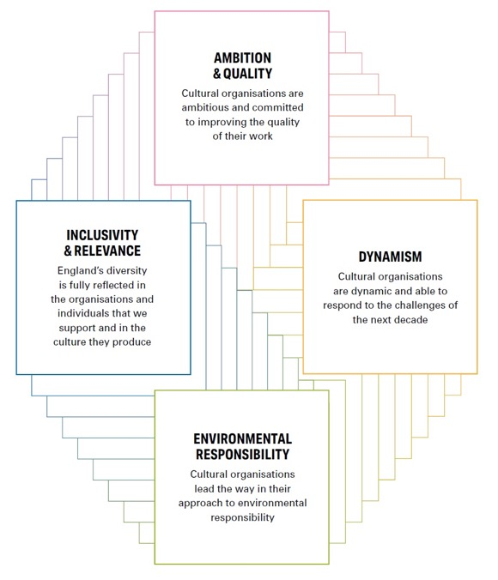
ACE Investment Principles

Our commitment
CHWA led a detailed collective response to Let’s Create in September 2019 with 39 signatories – which can be accessed here. We are thrilled to see the confirmation of the investment principles, which align strongly with our own vision, mission and priorities. We are particularly encouraged by the document’s reference to ‘initiatives around arts and health’ and the need to ‘adapt and expand’ these (p.5) and we are thrilled to see Priority D under ‘Cultural Communities’ devoted to health and wellbeing.

CHWA is committed to helping ACE deliver Let’s Create.

Connecting applicants with regional support
We wholeheartedly support Let’s Create’s commitment to innovation and risk. We also know there is a deep well of knowledge and experience in our networks which we hope organisations and individuals newer to this work will draw from. We will be seeking support from ACE to communicate information about CHWA – in particular connecting NPOs and other applicants who are newer to practice in relation to health and wellbeing to the core team and to our regional champions.

Existing work | Outline of evidence and data sets we will use

INCLUSIVITY & RELEVANCE
See our Equality Action Plan below. Surging awareness of national health inequalities, in combination with the light shone on structural racism by #BlackLivesMatter and critical movements from #WeShallNotBeRemoved to #UKExcluded has strengthened our focus on equity. Our contention is that bringing together the historically unequal spaces of culture and health allows us to challenge the limitations of each. We are committed to moving beyond a diagnosis-focused approach and working with the sector to understand the role of creativity and cultural engagement in an asset-based approach to health, and how we might positively impact the social determinants of health and foreground cultural activity that is already righting health inequalities.  Responding to the specific imbalances revealed by our Survey we continue to shift the focus of our events, website and bulletin to prioritise work led by people with lived experience, as well as people of diverse heritages and people identifying as Disabled.  We have pushed hard throughout 2020 to think beyond a purely digital response to the pandemic and recognise digital barriers that consistently overlap with poverty and poor health outcomes. Our reports have emphasised the importance of offline approaches – whether postal, phone, or socially distanced; we are also championing organisations who have provided additional digital support to participants otherwise excluded. We recognise there is a tension between our emphasis on online support for members and digital exclusion, which we will seek to address this year. | Our annual Equality, Diversity and Representation survey will be refined in its language to reflect ongoing debates and progress established by (for example) IncArts through its #BAMEover guidance.  We will also analyse attendance, speakers and performers at meetings using the same survey, to ensure we are prioritising under-represented groups in our public facing work. We understand that surveys have limitations and will be investigating other ways of assessing our performance.  We will establish and refine plans across 2021-23 for more robust analysis of our online resources and the organisations ad activities on which they focus, ideally in consultation with relevant SSOs and ACE’s digital champions.  We are consulting with Culture& in 2021-22 with a particular focus on the relevance of our events and proposed training.  Our most recent collation of case studies includes assessment of organisations’ focus on the protected characteristics. We will make this standard in all calls for evidence.  (We are already partnering with the UCL Community Covid study, which has a strong focus on remote creative practice and health inequalities.)  We will develop an assessment of CHWA’s own digital inclusivity.

DYNAMISM
CHWA is inherently dynamic, designed to respond to and support our membership and stakeholder groups’ needs.  We have adapted and increased activity significantly across 2020:  - Establishing a resources page in early March 2020 that has been updated regularly since  - Building rapid Guidance for working online in partnership with AMA, 64million Artists and Real Ideas  - Working with all regional champions and Strategic Alliance Members within the first fortnight of lockdown to compile a snapshot report of the sector for ACE and other partners  - Consistently gathering and distributing evidence of practice throughout lockdown  - Quadrupling our events and meetings to provide peer support through lockdown  Our Board has been equally responsive, meeting fortnightly in the early days of lockdown to provide extra support, shifting to monthly, and now every two months in response to the organisation’s needs.  Our larger aim is to amplify and support the dynamism of the culture, health and wellbeing sector – a collective example of innovation that has put our membership’s resources at the disposal of the communities around them to combat loneliness and isolation, and to build connections and community, through the most challenging times – demonstrating beyond doubt the central role culture and creativity have to play in building a healthy society. | We will monitor our own activity via Director’s Reports, which are delivered to the Board at each meeting and also shared with ACE via Grantium.  We have an ambitious outline plan for development across the next 7 years including the development of regional infrastructure, which we will be fleshing out through the consultancy process with the Board (see below).  Progress against agreed targets for 2021-22 is described below and will be extended in our 9 June Business Plan and our main SSO bid in 2022. Progress will again be monitored by the Board.

AMBITION & QUALITY
Our ambition is to drive the culture, health and wellbeing sector forward in partnership with our stakeholder groups and others. To succeed we need to build an infrastructure that allows us to meet health, social care and local government on equal terms. We anticipate that regional and local networks will play a critical role in the next 5-10 years, and are making the case for greater investment here from 2023.  The question of quality is itself complex and we have long argued for conceptions of quality to be determined by process and engagement rather than purely outputs. With our academic and practice partners we aim to work on clearer conceptions of ‘quality’ in socially engaged work. This may evolve into a Code of Practice which can act as a broad guide to the sector without curtailing specific approaches.  We also aim to encourage a sea change in the sector, learning from existing best practice that works beyond health conditions to consider health inequalities and the social determinants of health. | Our annual culture, health and wellbeing survey (a ‘state of the sector’ survey rather than a survey of the Alliance itself) will be refined in collaboration with the University of Chester who are developing a new survey model based on their analysis of the May 2020 survey.  Developing our membership model will allow us to understand what is valued most about CHWA, where we can provide additional support, and what quality might mean for CHWA itself. We will consider markers for quality that would support our regional champions as well as core staff and Board, and by which members and partners might be able to assess our performance.  We will also develop case studies with partners and stakeholder groups to help describe CHWA’s impact in the sector.

ENVIRONMENTAL RESPONSIBILITY
CHWA has no office space and even prior to lockdown created a minimum of physical materials barring an annual artists’ commission to create our Awards (the commission requires these to be created with sustainability in mind).  Because we convene stakeholder groups on a regular basis and run an annual conference, our main environmental challenge is travel to meetings and events.  Our Climate policy strictly limits our air travel, commits us to supplying only vegetarian or vegan food at events, and provides guidance on procurement. Along with everyone else our travel and subsistence has dropped to a micro % of what it was. We will pursue a blended approach to events and meetings that will allow us to support some face-to-face work, whilst improving international access and reducing travel. We plan to reduce face-to-face meetings to one per year from quarterly for all stakeholder groups, from 2021-22 onwards.  Developing practice  Our broader concern is to join the dots between creative and cultural work we support and the ways in which health is impacted by social determinants such as environmental degradation and migration. We are also aware that partnership with organisations engaged with nature and the environment will be critical for our sector as social prescribing takes shape, and we are building relationships with Natural England, the NLHF and others.  We lead a consortium in Julie’s Bicycle’s Accelerator programme with London Arts in Health, Arts & Health South West and the National Network for Arts, Design & Heritage in Healthcare, with a view to catalysing innovation in the wider sector.  We host an annual Climate Award and (new this year) have begun a series of blogs with a focus on nature. | We collect data on our own travel and consumption via our accounting processes.  We will monitor the regularity and impact of face-to-face meetings and events once the pandemic has stabilised.  We will be evaluating the success of an online conference with a view to switching to primarily online events. We will also monitor the digital environmental costs of conferencing online via new tools currently being developed as part of the Julie’s Bicycle cohort, by Fast Familiar, Abandon Normal Devices and Arts Catalyst. We will need to find a balance across 2021-23 between ensuring people are included who may not be able to access work digitally, and minimising our carbon footprint.  Data for developing practice  Through our Accelerator project we are collecting case studies of enablers and barriers for work that connects climate change, health, creativity and culture.  Our climate award also provides a number of case studies of best practice across the sector.

Dedicated time with the board and staff to embed the Investment Principles
Our Board has engaged with the process of developing this Business Plan (see Board minutes from meeting of 22 March 2021). We are holding two Board “away-days” facilitated by David Bryan. The first will be in May 2021, to help us prepare for the June 2021 extension application, and the second in August/Sept 2021 to support the process of the full SSO application for 2023. Both sessions will focus on developing our core capacity and regional infrastructure through a consideration of the investment principles and our strategic priorities, outlined below, including our longstanding commitment addressing health and cultural inequalities.

2021-22 Business Plan

Activity Plan 2021-22
(NB This is the same information as that given in the ACE template)

Activity Plan 2021-22 (detail)

Equality Action Plan / Developing membership

Our Equality Action Plan governs the following planned developments. The EAP is subject to ongoing development as we flesh out the what advancing healthy equality means to us as an organisation, and to the sector as a whole. We will be turning our insights into a fuller EDI action plan for internal and external activities for the extension and full SSO bid.

Analysis of membership's diversity
We conducted an Equality, Diversity and Representation survey in August 2020. The results are here, along with comparative national data where we have been able to source it, and a brief commentary. Key areas of divergence with national figures are highlighted. We will conduct this survey annually to monitor progress against our target of improving our diversity against national comparators.

New co-chair with health inequalities experience
CHWA’s structures are already to an extent democratic and focused on partnership and consensus-building, but we continue to work on flattening hierarchies, based in part on 2018’s Changing Cultures report and recommendations for more collaborative models of leadership to ensure a more diverse and representative sector.

Our Board of Directors is made up of people experienced in work with culture, health and wellbeing from a variety of perspectives – but lacks specific professional expertise in health and health inequalities, social care and local government. We are therefore seeking a Co-Chair expert in health inequalities with a view to appointing in late summer 2021. We will be actively researching potential applicants April-June, and seeking applications from groups currently under-represented in the board and staff (again, see our EDR survey here), using guidance from ACE’s Equality Action Guide.

Elected regional champions
Our regional champions are now subject to an election process upon stepping down. This process was conducted successfully in the West Midlands region (May/June 2020) and will be used as a template for future elections. In each re-election we will work with regional champions to broaden the region’s membership by reaching out beyond existing networks– in particular to organisations focusing on health and cultural in/equalities – prior to election processes.

Financial compensation for LENs and freelancers
We are committed to providing honoraria for LENs members to attend quarterly Steering Group meetings as they become an independent entity, and before they are able to fundraise independently. We hope to extend this commitment to all freelancers within our Strategic Alliance Members and Regional Champions groups in 2021-22.

Strategic Alliance Membership development
From summer 2021 we will be working with our Strategic Alliance Members group to build a new and simpler MOU between members and CHWA, and to bring in new members whose focus is overtly cultural and/or health inequalities.

Developing membership offer
CHWA’s membership has grown rapidly from 1,866 in April 2018 to 5,402 on 10 March 2021.

Our membership is active and engaged: despite the pressures on the sector we have gathered 125 case studies from around the country since March 2020, and conducted a survey in May 2020 with 220 detailed responses. We know from Mailchimp that 52% of our membership engage with us “often”. Inquiries to the info@ email address averaged 38 per month from our inception to March 2020, rising to 42 per month this year. We offer bespoke support to everyone enquiring, providing information on (e.g.) social prescribing or specific areas of practice, often connecting people with regional champions or national partners, or following up with meetings.

Consultation & development of fee-paying offer
We will consult our members and stakeholder groups on CHWA membership in 2021-22
- to understand what is working well about membership and what we need to change
- to review our Equality Action Plan
- to support our efforts to diversify our funding
This will involve a questionnaire that builds on our previous annual surveys, and a more detailed consultation process with a snapshot of c.18 members from around the country (two from each region).

The question of payment for membership has been debated for many years in regional and national networks for culture, health and wellbeing. A third of respondents to our May 2020 survey were freelancers or self-employed; another third employed under 15 people. These individuals and organisations are already in financially precarious positions and especially vulnerable to the financial crisis pursuant to the pandemic. The people who fill in our surveys and submit case studies are also contributing to the value of the organisation in kind, and we are extremely keen to ensure that nothing stands in the way of these groups benefitting from and contributing to the Alliance.

Possible models include maintaining a baseline free membership offer, and charging a proportion of members who may be in better-funded organisations, or charging for specific elements of membership that may be easier for members to assign to budget lines (access to the training suite described below, for example). There is a strong existing sense of concern and responsibility across the sector for our freelance colleagues (see this March’s snapshot report) and we believe member organisations will welcome the chance to offer in-kind support in this way.

In 2021-22 we will also be building a suite of online training available for the sector. This is pre-existing training – much of which has been developed by SAMs or regional champions but which has not so far been gathered in one space.

We also need to develop means for members to communicate directly online without mediation from CHWA staff, and for regional champions to communicate direct with regional groups within GDPR rules.

Regional support
CHWA’s regional champions – working with regional LENs champions – have committed significant time and energy to building networks and connections across the nine regions of England. The work has varied region-to-region according to capacity and local need, but includes the successful formation of steering groups and networks, effective and influential events and training, and fast-growing membership. Champions have represented CHWA at national and international events and meetings and their work to gather and spread information across their regions has directly fed into reports and conversations with national strategic partners from NHS England to ACE.

It is clear that regional and local networks will be essential, mostly obviously in relation to social prescribing, which will rely on regional and local coordination for the sector to be able to meet new NHS systems on equal terms.

Notwithstanding the significance and success of our voluntary champions’ work, it is both unrealistic and unfair to expect this complex work to be pursued on an entirely voluntary basis – especially with the additional burdens and complications created by the pandemic.

We see the champions’ roles as essential to the development of the sector, but we also know that we need funding in each region of the country to provide logistical and administrative support to complement these roles.

CHWA’s capacity to manage regional coordinators is limited. We have therefore established a roadmap to take us towards this position between 2022 and 2025. Our current proposal is for CHWA to employ
- Seven* regional coordinators 1 day p/w by April 2023, rising to 2 days p/w by April 2024
- The coordinators would work in collaboration with regional champions, supporting logistics and administration for regional networking
- To balance the cultural expertise of our regional champions and to further the need to address health and cultural inequalities we will be seeking coordinators who have experience in inequalities and who will bring contacts that widen existing cultural networks
- We anticipate that regional coordinators posts will grow and become more independent with time

*To complement existing funded networks in London and the South West.

Mapping & research

Analysis of lockdown work and CHW survey
CHWA has collected 100 case studies of work reaching people shielding at home, and people resident in hospitals, care homes, hospices, prisons and other institutions during the pandemic – the latter in partnership with Live Music Now, Music for Dementia, Music in Hospitals and Care, the National Criminal Justice Arts Alliance, the National Performance Advisory Group (NPAG) for Arts, Design and Heritage in Healthcare, Paintings in Hospitals and Performing Medicine.

“This [shielding report] is incredibly useful and will be of significant value to us in our engagement with senior decision makers on the value the creative industries provides to society. We will be sure to keep in touch with you on our work in this area.” (Creative Industries Federation)

“It was a massive task to put so many case studies together in such a short space of time. They are really great resource as it’s so useful (and cheering) to know what other organisations are doing.” (CHWA member)

“I look forward to diving in to the report and would like to thank you for your commitment to this agenda and for enabling us to contribute to this important work.” (CHWA member)

Our report on work for people shielding at home was released in July 2020 and circulated to the APPG prior to its 16 July meeting. We will be releasing a report on institutional work in April/May 2021 with a series of recommendations.

The Culture, Health & Wellbeing Survey has been subject to some analysis already, which has usefully revealed patterns of funding and the size and focus of organisations in the sector. We are partnering with the University of Chester to release further analysis in 2021-22.

Accelerator programme: climate, creativity and health
CHWA is leading a consortium with London Arts in Health, Arts & Health South West and the NPAG for Arts, Design & Heritage in Healthcare as part of Julie’s Bicycle’s Accelerator programme – which aims “to advance …sustainable practice and share insights with peers and the wider sector”. We are working with independent researcher Frances Northrop to build a picture of existing practice and help catalyse innovation; develop our intersectional understanding of climate, creativity and culture, and health and wellbeing; and offer funders and commissioners a vision of what is possible if barriers are removed.

Sustainable practice in mental health and the arts
The Culture, Health & Wellbeing Alliance is leading a 6-month project funded by the Baring Foundation, to understand how we might help more people and organisations survive and thrive in mental health and the arts. Our advisory group is drawn from diverse specialist organisations around the UK.

Events & Annual Awards

Spring/summer 2021: a season of culture, health and wellbeing
Across spring and summer 2021, the Culture, Health & Wellbeing Alliance, Arts & Health South West, and London Arts in Health are coming together with many other partners to stage a series of events celebrating the power of creativity and culture to transform our health and wellbeing:

A Culture of Care national conference (21-23 April 2021)
Our national conference will be held online across 3 days, ending with the CHWA 2021 Awards. Our core theme – care – includes caring for each other, caring for the environment and caring economies. We will be delving into conversations about topics amplified by Covid-19, including practitioner support and grappling with the sector’s role in challenging health inequalities, reflecting on how we can work more collaboratively and more intersectionally to address the multiple emergencies we face; a global health pandemic, the climate and ecological emergency, and rising inequality.

Creativity & Wellbeing Week (17-24 May 2021)
London Arts and Health (LAH) and CHWA will be partnering for the third year to host Creativity & Wellbeing Week 2021. This national festival is an opportunity for showcasing the huge breadth of work across the sector. Last year around 1,000 people attended events jointly curated by LAH and CHWA during the week, with many more attending other events organised by participants in the week. We had 250+ individual uploads to the site, some events, some organisational details, some information about offline work. A summary report from last year’s event is available here.

International Conference (21-23 June 2021)
The International Conference for Culture, Health & Wellbeing is undertaken every four years on behalf of CHWA by Arts & Health South West. This is the last international conference AHSW will run, with the responsibility falling to CHWA for 2025. The conference themes are Inequality, Power and Sustainability.

CHWA 2021 Awards
The CHWA Awards cover three themes:
- Collective Power, in partnership with Ideas Alliance and focusing on cross-sector partnerships
- Practising Well, in partnership with Nicola Naismith and focusing on support for practitioners
- Climate, in partnership with Happy Museums and Culture Declares Emergency
We have received around 100 applications and will be announcing winners at a public event which will also close our national conference on 23 April. Last year’s awards event can be viewed here. We also commission an artist each year to create the Awards.

“As an artist this has been a very rewarding experience and boosted my confidence as a maker greatly […] I very much enjoyed being part of the CHWA team. This positive experience has empowered me to explore further commissions and new directions in my work.” (Elaine Lim Newton, 2020 commission)

Regional events
Last year our regional champions led a number of events with our support. Yorkshire & Humber champions ran a series of Creative Well sessions with Integrative Arts Psychotherapist Roshmi Lovatt after a clear demand for additional support for practitioners and museum professionals arose in regional meetings. Other regions participated in November’s Winter Gatherings, a series of regionally-focused events around the country. Event plans for 2021-22 will be led by regional champions.

“It was great to be involved in the event in November and so refreshing to meet and speak with such brilliant people like yourself making a difference to communities.” (Winter Gatherings panellist)

Developing an inclusive events programme
We will be working Culture& in 2021-22 to develop an inclusive events programme.

Partnerships
(See The Alliance, above.)

LENs
The first LENs Directors were appointed by its Steering Group in March 2021. CHWA will continue to support the LENs to become a CIC in 2021-22 including through honoraria for LENs Steering Group members’ time. LENs Steering Group members will continue to observe the CHWA Board.

“it’s been a crazy and challenging year but working with the LENs and CHWA has been so great and rewarding to see what can achieved despite adversity and doubt.” (LENs steering group member)

National Centre for Creative Health / APPG
We have an MOU with the NCCH and LENs and will meet on a monthly basis as soon as NCCH Trustees have been appointed (?summer 2021). The NCCH and CHWA will jointly chair the SAPs group and jointly manage the APPG. We will collaborate on at least one project this year.

Action plan for Strategic Alliance Partners
The SAPs has been an effective space for exchange of information across the government agencies. Across 2021-22 we will be reorganising this group to be co-chaired by CHWA and the NCCH, who will develop a joint briefing paper for the SAPs to align with our strategic priorities, and set out an action plan for the group.

Our partnership with ACE is more embedded and includes regular monthly meetings with John McMahon (Senior Manager, Policy & Research), as well as collaboration between regional ACE Health & Wellbeing champions and our own regional champions.

NASP (National Academy of Social Prescribing)
A partnership between CHWA and NASP was announced at the NASP launch in March 2020. We have since been supported by Bev Taylor, strategic lead for NASP, in our VCSE Health & Wellbeing Alliance bid. The partnership has been dormant, however, with the drains on both NASP and CHWA’s capacity. We hope to revive this partnership in 2021-22 once we know the outcome of the VCSE HW Alliance bid.

Active research partnerships
There is a longstanding need to strengthen the connection between research and practice in this sector. We are committed to modelling active research partnerships for the sector, and in 2021-22 hope to change the way we work to ensure we are written into bids as active partners who will be supported financially by bids, and will in turn support research design, rather than rubberstamping and disseminating existing plans that may not adequately respond to practice.

We are currently engaged in the following research partnerships:
- Analysing 2020 Survey (University of Chester)
- Community Covid (AHRC/UCL)
- Social prescribing research (AHRC/GLAM/Uni of Oxford)
- AHRC/Centre for Performance Science (Imperial/RCM): creative practitioners’ wellbeing during covid
- RSPH SIG for Arts, Health & Wellbeing

We work with all our academic partners to support their understanding of practice, to develop a better balance of power between research and practice, to offer targeted approaches to organisations with specialist foci, and to collect data from our membership and via stakeholder groups.

Event partnerships
See Events, above. For information on partnerships across government agencies, see also Strategic Alliance Partners, above.

Ongoing work

Fundraising

Diversifying our funding
In November 2020 our Board met to begin the process of developing a strategic fundraising plan. This is tied closely to the staffing Roadmap described above. During 2021-22 the Board will develop this plan.

Like most of the organisations we support (see our survey), we are currently dependent on Trusts and Foundations, and of course on our ACE grant. Our immediate aim is to work out how to effectively diversify our funding model – considering for example funded partnership work through SLAs and some charges for our services to members (see Developing membership offer, above). We have begun this process by shifting towards more active partnership in research, which requires research leads to support our time in their bids, and by charging for consultancy support where appropriate.

Bids
Our main focus is our renewed SSO bid for 2023. We are also applying across 2021-22 to
- Awards for All in partnership with the LENs, to support strategic development for both LENs and CHWA
- ACE project grants to support a more inclusive events programme
- Paul Hamlyn Foundation to support regional development
- National Lottery Heritage Fund in partnership with GEM, to support training at Board/Director level for the museums sector
And others to be confirmed…
We are awaiting the results of a bid to the VCSE Health & Wellbeing Alliance (our bid included a letter of support from John McMahon at ACE).

Staff roadmap

Orange = additional posts or increases to time/salary

Blue = estimated increase in p.a. funding required. New increase in bold. (Sustained increase in brackets.)

Communications

Website & bulletin
The site and bulletin are constantly developing resources. The site includes focused areas on social prescribing, on research and evaluation and on climate. The bulletin updates the sector on relevant policy developments, research, sector news and best practice.

Since summer 2020 we have been commissioning blogs with a focus on fostering equity, including from Maxwell Ayamba, Errol Francis and Esther Fox, as well as Director’s blogs. The Exec Director also regularly publishes in magazines and journals, including most recently Germany’s Kubia magazine.

“Earlier today I was sharing 5-star CHWA resources with struggling heritage sector colleague” (SAPs member)

“Thank you for your hard work with CHWA and can I just add that your newsletter is the best one! I look forward to it landing in my inbox.” (Regional champion)

“your article about arts, health and wellbeing in old age that we published in our last Kubia magazine was of great interest for many of our readers: We are very happy about that!” (Editor, Kubia)

“Thank you for your generous coverage of our work - it’s very validating, and means a lot to the whole team of artists and participants alike who are always steadfast in their absolute dedication and passion.” (CHWA member)

Marketing/fundraising support
There is significant feedback from the sector that its story is not being heard publicly or at the highest levels of government/commissioning. We are producing high volumes of timely and relevant work (see Mapping & Research above), but we need marketing support to ensure that this work is reaching the right audiences. In 2021-22 we plan to work with partners who have marketing resources where possible (as we have this year with Create) and with freelance marketing support where budgets allow.

Evaluation

Developing data sets to meet Investment Principles
See Investment principles, Outline of evidence and data sets, above.

Annual survey
We conduct an annual survey to assess how useful our members are finding various aspects of the Alliance, including the website, bulletin and whether they or their organisation has been specifically supported by CHWA. These are published on our website.

Our survey in 2018-19 garnered many more responses (99) than 2019-20 (just 10). We ascribe this largely to survey fatigue in the second half of 2020. (CHWA itself had also conducted a successful call for case studies and a wide-reaching sector survey, as well as promoting a number of other sector surveys from research partners.) We will however extend our assessment by conducting snapshot interviews with 18 members in 2021-22.

Annual EDR survey
See Equality Action Plan, above.

Comments, complaints, compliments
All comments, complaints and compliments are logged and acted on according to our policy.

Risk Register
Our Risk Register is updated and assessed in the Director’s report for each Board meeting.

Logging enquiries
We log all enquiries to the CHWA email addresses.

“Thank you so much for getting back to me so quickly, and with such an amazing collection of organisations to contact, I really appreciate it. I'll start making enquiries immediately.”

Budget

 | Agreed by Board 22 March
Income
Opening Balance | 10500.00
ACE | 96748.00
Earned income: Events | 15000.00
Earned income: Regional events | 1200.00
Baring Foundation | 20000.00
VCSE HW Alliance | 90000.00
Donations | 1000.00
Additional grants/commissioning | 55000.00
Sponsorship | 1000.00
Total cash income | 290448.00
Expenditure
Staffing and governance
Staff (Exec Director) | 45000.00
Employer's NI Contributions (ED) | 4997.76
Employer's Pension Contributions (ED) | 1162.80
Staff (Co-ordinator) | 18576.00
Employer's NI Contributions (Coordinator) | 1321.44
Employer's Pension Contributions (Coordinator) | 363.60
AHSW Director: APPG/Inquiry/management | NA
Fundraising & marketing | 5000.00
Finance Officer | 4000.00
LENS meetings | 6900.00
Freelancer stipends | 1500.00
Steering Committee | 3000.00
Board | 1000.00
LENS Steering Group | 3000.00
Events and regional development
Events | 10000.00
Regional development | 13775.00
Regional events
Online resource | 2500.00
Commissioned/grants services
Baring Foundation | 14000.00
VCSE HW Alliance | 80000.00
Additional commissioned or grant programme delivery costs | 45000.00
Running costs
1% of core (EDI) | 1000.00
Staff training/CPD | 2000.00
Xero subscription | 345.60
Mailchimp subscription | 900.00
Zoom subs | 180.00
Subsistence costs | 500.00
Equipment/IT etc | 1000.00
Travel | 5000.00
Phone | 200.00
Materials and office costs | 100.00
Accountancy, audit, bookkeeping, bank charges, payroll | 2500.00
Insurance | 750.00
Sub total | 275572.20
Contingency | 10000.00
Total cash expenditure | 285572.20
Balance | 4875.80

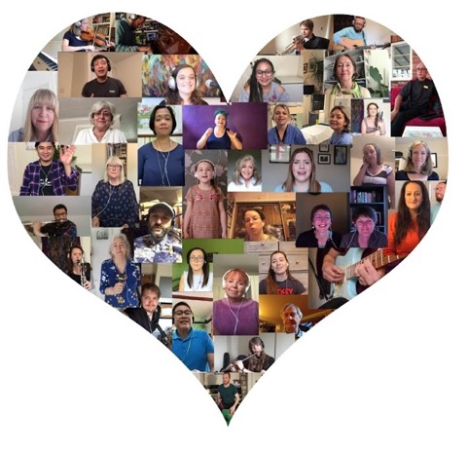

Air Arts, University Hospitals
of Derby & Burton: “A Grateful Heart”

Changing cultures: Transforming leadership in the arts, museums and libraries (Arts Council England/King’s College London and Sue Hoyle, 2018); https://www.artscouncil.org.uk/publication/changing-cultures-transforming-leadership-arts-museums-and-libraries.
See Rolling Out Social Prescribing (National Voices, September 2020), available at https://www.nationalvoices.org.uk/publications/our-publications/rolling-out-social-prescribing.

